**Hackathon Project Report on**

**E**co**F**inds

Deals for you, wins for Earth.

EcoFinds: Sustainable Second-Hand Marketplace

Submitted by:

* *Vatsal Mangalbhai Patel* (Team Lead)
* *Honey Keyur Panwala*
* *Lovekesh Chandrakumar Shukla*
* *Arya Dash*

*Hackathon: Odoo x NMIT Hackathon 2025*

*Date of Submission: 6th September,2025*

*“Because every reused product is one less strain on the planet.”*

This report presents the design and development of **EcoFinds**, a structured web application created to demonstrate the process of building a functional online marketplace. The project was developed using **Django** as the core backend framework, supported by **Django templates and HTMX** for responsive and interactive interfaces.

The system provides the following key features:

* **User Authentication & Profile Management** – allowing users to register, log in, and maintain personal profiles.
* **Product Listings & CRUD Operations** – enabling sellers to add, edit, delete, and manage their items.
* **Search and Filtering** – to improve discoverability of listed products.
* **User-Specific Listings** – showing sellers only their own products for easy management.
* **Cart and Mock Checkout** – simulating an online purchase experience.
* **Order History** – allowing users to track previous purchases.
* **Responsive Templates & Seed Data** – ensuring usability and ease of demonstration.

The development process followed a **checklist-driven methodology**, where each module was broken down into smaller, verifiable tasks with clear acceptance criteria. This approach ensured that the application was developed systematically, maintaining both functionality and clarity.

# **📑 Project Report Index – *EcoFinds***

## **Section A – Front Matter**

* Title Page
* Certificate
* Acknowledgment
* Abstract
* Table of Contents

## **Section B – Introduction & Background**

* Introduction to the Project
* Background of Online Marketplace
* Problem Statement
* Objectives of the Project
* Scope of the Project
* Significance of the Project
* Limitations of Existing Solutions
* Literature Review / Related Work

## **Section C – System Analysis**

* System Requirements Specification (SRS)
* Functional Requirements
* Non-Functional Requirements
* Stakeholder Analysis
* Use Case Identification
* Use Case Descriptions
* Feasibility Study

Technical Feasibility

Operational Feasibility

Economic Feasibility

## **Section D – System Design**

* System Architecture Overview
* Detailed Architecture (Django MVC flow)
* Module Description
* Use Case Diagram
* Class Diagram

## **Section E – Website Work**

Screenshots from

* Dashboard
* Homepage
* Product Catalogue
* Cart
* Orders Page
* Search

Conclusion

**📘 Introduction & Background**

**Introduction to the Project**

The digital age has ushered in a new era of connectivity and commerce, transforming how individuals interact, exchange resources, and conduct business. At the forefront of this transformation are online marketplaces, which have profoundly redefined traditional models of buying, selling, and trading goods. The remarkable success of peer-to-peer (P2P) commerce platforms such as OLX, Quikr, and eBay stands as a testament to the immense potential of these systems in fostering community-driven exchange and democratizing access to various products. These platforms have demonstrated their ability to connect diverse users, facilitate countless transactions, and even contribute to more sustainable consumption patterns by enabling the re-use and re-selling of items.

However, the creation and deployment of such sophisticated digital marketplaces within an academic or developmental context often presents a formidable challenge. Students, developers, and even seasoned teams frequently encounter significant hurdles in project structuring, module prioritization, and the timely delivery of functional prototypes. These complexities are further magnified by the inherent interconnectedness of marketplace systems, which typically necessitate the seamless integration of multiple critical modules. These include, but are not limited to, robust user authentication and authorization, intuitive product listing and management, efficient cart functionality, secure order handling, and often, integrated payment gateways. Each of these modules brings its own set of dependencies and development considerations, making the overall project highly intricate.

It was against this backdrop of both opportunity and challenge that EcoFinds was conceptualized and meticulously developed. This project serves as a comprehensive demonstration of how a complex online marketplace system can be systematically constructed using a structured, checklist-driven methodology. The name "EcoFinds" was deliberately chosen to encapsulate the dual core vision of the project. Firstly, it signifies the development of an environmentally conscious digital exchange platform, primarily focused on promoting the re-use and re-selling of pre-owned or surplus items, thereby contributing to a more circular economy. Secondly, "Eco" also alludes to the creation of a methodical "ecosystem" of project tasks, ensuring a comprehensive and complete development process. This approach emphasizes meticulous planning and systematic execution to guarantee that all essential functionalities are addressed.

The technical foundation of EcoFinds is built upon Django, a high-level Python web framework renowned for its inherent robustness, impressive scalability, and rapid development capabilities. Django's powerful templating engine, when combined with HTMX (HTML Over The Wire), provides an elegant and efficient solution for crafting highly responsive and interactive front-end interfaces. This synergistic pairing allows for the creation of dynamic user experiences without introducing the often-unnecessary complexity associated with full JavaScript frameworks. The resulting system is remarkably lightweight and performant, yet fully capable of showcasing and demonstrating all the essential features and core functionalities expected of a modern online marketplace.

In essence, EcoFinds transcends being merely a finished product; it embodies a process—a tangible demonstration of how strategic planning and a disciplined, structured approach inevitably lead to efficient and effective project execution. It skillfully bridges the critical gap between conceptual design and practical implementation, meticulously ensuring that all vital functionalities inherent to a marketplace system are thoroughly covered. Crucially, this is achieved while remaining entirely achievable within the typical constraints of limited timelines and available resources, making EcoFinds an invaluable blueprint for aspiring developers and a testament to the power of systematic project management.

**Background of Online Marketplaces**

The dawn of the internet ushered in a new era of commerce, fundamentally transforming how goods and services are exchanged. Over the past two decades, e-commerce and online trading have not merely grown, but have experienced exponential, unprecedented expansion. This digital revolution has shifted consumer behavior dramatically; individuals now instinctively turn to digital platforms not only for brand-new products from manufacturers but also for a burgeoning market of re-sold, refurbished, or pre-owned goods. This transition has been pivotal in fostering a more sustainable economic model.

Marketplaces that facilitate the exchange of these goods have become central to the concept of a "circular economy." Unlike the traditional linear model of "take-make-dispose," a circular economy emphasizes keeping resources in use for as long as possible, extracting the maximum value from them while in use, and then recovering and regenerating products and materials at the end of each service life. By enabling products to be reused instead of being discarded, online marketplaces significantly reduce waste, minimize the consumption of new resources, and maximize the utility of existing items. This aligns with global efforts to combat environmental degradation and promote responsible consumption.

A typical online marketplace system, regardless of its scale or specific niche, generally integrates several fundamental features to ensure a functional and user-friendly experience:

* User Authentication: This is the bedrock of any secure online platform. It involves robust mechanisms to identify and verify user identities, protect sensitive account information, and prevent unauthorized access. This often includes features like registration, login, password management, and multi-factor authentication.
* Product Listings: This core feature allows sellers to effectively display and manage details of items they wish to sell. A comprehensive product listing typically includes high-quality images, detailed descriptions (including condition, specifications, and features), pricing information, shipping options, and inventory management capabilities.
* Search and Filtering Mechanisms: To ensure buyers can efficiently navigate vast inventories, powerful search and filtering functionalities are crucial. These mechanisms allow users to discover items based on keywords, categories, price range, condition, brand, location, and other relevant attributes, significantly improving the user experience.
* Cart and Checkout Features: These features provide a seamless and intuitive transactional flow for buyers. A well-designed cart allows users to accumulate multiple items before purchase, while the checkout process guides them through payment, shipping address input, and order confirmation, ensuring a smooth and secure transaction.
* Order History and Management: This essential feature provides both buyers and sellers with comprehensive records. Buyers can track past purchases, view order statuses, and manage returns, while sellers can monitor their sales, track shipments, and manage their inventory efficiently.

However, the reality of most large-scale commercial online platforms is that they implement these fundamental features with significant layers of complexity. This often includes sophisticated payment gateway integrations (handling various payment methods and currencies), intricate logistics management (coordinating shipping, tracking, and returns), advanced recommendation engines (personalizing user experiences based on past behavior and preferences), and large-scale analytics (providing insights into market trends, user engagement, and sales performance). While these advanced features are critical for commercial success, for educational or prototype-level development, they often become significant distractions. The overhead and complexity associated with building and integrating these features can prevent a project from reaching completion within a reasonable timeframe or scope.

Recognizing this challenge, EcoFinds deliberately avoids unnecessary overhead and instead focuses meticulously on building a robust and functional foundation of essential marketplace features. By prioritizing the core functionalities—user authentication, product listings, search/filtering, cart/checkout, and order management—EcoFinds ensures that the project remains realistic in scope and achievable within typical development constraints. This focused approach allows the project to effectively capture the essence of how such platforms operate, providing a clear and understandable model without getting bogged down by the complexities that are often peripheral to the fundamental learning objectives of a prototype.

**Problem Statement: Navigating the Complexities of Online Marketplace Development in Constrained Environments**

Developing a robust and functional online marketplace presents a unique set of challenges, especially when operating under the tight constraints of academic schedules, limited development cycles, or resource-scarce environments. These limitations frequently lead to project outcomes that are incomplete, lack structural integrity, and are insufficiently tested. The inherent complexity of replicating real-world e-commerce systems often proves overwhelming for developers with finite time and resources, resulting in a common set of recurring issues:

1. Over-ambitious Scope and Unrealistic Expectations: A prevalent pitfall is the attempt to build an industry-scale system within a timeframe and with resources that are inherently insufficient. This often leads to feature bloat, where developers try to incorporate too many functionalities, many of which are non-essential for a minimum viable product. The aspiration to mimic established platforms like Amazon or eBay without the corresponding infrastructural and human capital backing often results in a fragmented and under-developed product.
2. Absence of a Structured Development Methodology: Without a clear, step-by-step approach, development efforts can quickly devolve into chaos. The lack of defined module priorities, ill-defined interdependencies between components, and an absence of a systematic workflow can cause significant confusion. This unstructured approach hampers progress, makes it difficult to track development, and often leads to last-minute, rushed implementations of critical functionalities.
3. Persistent Integration Issues Between Core Modules: A marketplace system is inherently modular, comprising distinct yet interconnected components such as user authentication, product listing and management, inventory control, payment gateways, and transaction processing. Seamless integration of these diverse modules is paramount for a cohesive user experience. However, developers frequently encounter difficulties in achieving smooth data flow and communication between these disparate parts, leading to disjoined functionalities, data inconsistencies, and a poor overall user journey.
4. Inconsistent Validation and Inadequate Error Handling: A reliable online marketplace must provide a predictable and forgiving user experience. This necessitates robust input validation, ensuring data integrity and preventing malicious inputs. Equally crucial is comprehensive error handling, where the system gracefully manages unexpected situations, provides clear feedback to the user, and prevents system crashes. The absence of consistent validation rules and a well-defined error handling strategy inevitably leads to unreliable user experiences, data corruption, and a perception of an unprofessional and unstable platform.

This project, "EcoFinds," directly addresses these critical challenges by championing a pragmatic, checklist-oriented development methodology. This systematic approach aims to bring order and clarity to the often-turbulent process of building a marketplace. Each task within the EcoFinds development framework is meticulously defined with four key attributes:

* A Clear Objective (What to Build and Why): Every development effort begins with a precise understanding of its purpose. This objective clarifies the specific functionality to be implemented and articulates its value proposition within the broader marketplace ecosystem. This ensures that all development is purposeful and aligned with the overarching project goals.
* A Short Technical Description (How to Build It): Once the objective is clear, a concise technical outline details the chosen approach for implementation. This includes outlining the technologies, algorithms, and architectural patterns to be employed, providing developers with a clear roadmap for execution.
* A Realistic Time Estimate (To Stay Realistic): To combat the issue of over-ambitious scope, each task is assigned a realistic time estimate. This encourages developers to break down large problems into manageable chunks and helps in effective project scheduling and resource allocation, preventing burnout and missed deadlines.
* An Acceptance Criterion (To Verify Completion): Crucially, every task is accompanied by a set of verifiable acceptance criteria. These criteria define what constitutes a successful completion of the task, enabling rigorous testing and ensuring that the implemented functionality meets the required specifications and quality standards. This objective measure of success prevents ambiguity and facilitates efficient quality assurance.

By meticulously adopting this checklist-oriented methodology, EcoFinds tackles the central problem head-on: the pervasive lack of structured, practical guidance in creating a working marketplace system at a manageable and achievable scale. The project aims to demonstrate that even within significant constraints, a well-defined process can lead to the successful development of a functional, reliable, and user-friendly online marketplace.

**Comprehensive Objectives of the EcoFinds Project**

The EcoFinds project is designed with a dual focus, encompassing both rigorous technical implementation and a well-structured methodological approach. These objectives ensure the creation of a robust and user-friendly sustainable marketplace while also serving as a model for efficient project management.Detailed Technical Objectives

The technical objectives outline the core functionalities and architectural considerations crucial for the successful operation of the EcoFinds platform:

1. Secure Authentication and User Management:
   * Goal: To establish a highly secure and reliable system for user registration, login, and profile management.
   * Implementation: This involves developing robust password hashing, multi-factor authentication (MFA) options (e.g., email verification), and secure session management. The system will allow users to create unique accounts, log in securely, and personalize their profiles with relevant information (e.g., contact details, location, preferred payment methods). Robust access control mechanisms will be implemented to protect user data and prevent unauthorized access.
2. Product Management System with CRUD Operations:
   * Goal: To enable users to effectively manage their product listings through comprehensive Create, Read, Update, and Delete (CRUD) functionalities.
   * Implementation: Each user account will be linked to their own product inventory. Users will be able to effortlessly add new products, view existing listings, modify product details (e.g., price, description, images, quantity), and remove products that are no longer available. This system will include features for categorizing products, adding detailed descriptions, and uploading high-quality images.
3. Advanced Search and Category-Based Filtering:
   * Goal: To enhance product discoverability by providing intuitive and efficient search and filtering capabilities.
   * Implementation: Users will be able to search for products using keywords, and filter results based on various criteria such as product category (e.g., clothing, home goods, electronics), condition (new, used, refurbished), price range, and location. This will involve implementing a robust search engine (e.g., full-text search, indexing) and a flexible categorization system to ensure users can quickly find what they need.
4. User-Specific Product Listings Management:
   * Goal: To provide a dedicated and centralized space for users to manage their own product listings.
   * Implementation: A personalized "My Listings" or "Dashboard" page will be developed, allowing sellers to view all their active, pending, and sold products at a glance. This page will offer quick access to edit product details, monitor listing performance, and track inventory levels, providing sellers with comprehensive control over their offerings.
5. Interactive Cart System:
   * Goal: To design and implement a user-friendly shopping cart system that allows for seamless item management before checkout.
   * Implementation: Users will be able to add multiple products to their cart, adjust quantities, and remove items as needed. The cart will dynamically update total prices and reflect any applicable discounts. Features like "save for later" or "wishlist" may also be considered to enhance the shopping experience.
6. Simulated Checkout Process and Order History:
   * Goal: To simulate a complete checkout flow and maintain a detailed record of user transactions.
   * Implementation: While EcoFinds will simulate the checkout process, it will demonstrate the logical steps involved, including order summary review, "payment" method selection (e.g., "COD," "bank transfer," or a dummy payment gateway), and order confirmation. Crucially, a comprehensive order history will be maintained for each user, allowing them to review past purchases, track "order" statuses, and access "receipts."
7. Responsive and Consistent User Interface:
   * Goal: To create an aesthetically pleasing, intuitive, and consistent user interface across various devices.
   * Implementation: The application will be designed with a responsive layout using modern CSS frameworks (e.g., Bootstrap, Tailwind CSS) and templating engines. This ensures optimal viewing and interaction experiences on desktops, tablets, and mobile phones. A consistent design language, including color palettes, typography, and iconography, will be applied throughout the platform to enhance usability and brand recognition.
8. Robust Input Validation and Error Handling:
   * Goal: To ensure the reliability and stability of the system through comprehensive input validation and error handling mechanisms.
   * Implementation: All user inputs (e.g., registration forms, product details) will undergo rigorous validation on both client and server sides to prevent invalid data entry and potential security vulnerabilities. Clear and informative error messages will be provided to users, guiding them to correct mistakes. The system will also include robust backend error logging and graceful degradation to handle unexpected issues and maintain system uptime.
9. Seed/Demo Data Population:
   * Goal: To populate the system with a realistic dataset for effective demonstration and testing purposes.
   * Implementation: A comprehensive set of seed or demo data will be created, including various user profiles, diverse product listings across different categories, and simulated order history. This data will allow for thorough testing of all functionalities and provide a compelling demonstration of the EcoFinds platform during presentations, showcasing its full capabilities.

**Strategic Methodological Objectives**

Beyond technical implementation, the methodological objectives ensure a structured, efficient, and well-documented development process:

1. Checklist-Driven Development:
   * Goal: To ensure clarity, completeness, and accountability at every stage of the development lifecycle.
   * Implementation: A detailed checklist will be developed and followed for each major task and feature. This includes defining clear requirements, outlining design specifications, establishing testing criteria, and documenting completion. This systematic approach minimizes oversight, ensures all necessary steps are taken, and provides a clear roadmap for progress.
2. Modularity for Independent Development and Testing:
   * Goal: To promote independent development, facilitate testing, and enhance maintainability of the codebase.
   * Implementation: The project will be architected with a modular design, breaking down complex functionalities into smaller, independent components. This allows different team members to work on separate features concurrently without significant dependencies. Each module can be developed, tested (e.g., unit tests, integration tests), and deployed independently, simplifying debugging and updates while improving overall code quality.
3. Achievability within Resource Constraints:
   * Goal: To ensure the project remains realistic and demonstrable within the allocated time, budget, and human resources.
   * Implementation: Regular progress assessments and scope management will be conducted to ensure the project stays on track. Features will be prioritized based on their impact and feasibility. This objective emphasizes efficient resource allocation and pragmatic decision-making to deliver a functional and impactful product within practical limitations.
4. Systematic Documentation:
   * Goal: To create comprehensive and systematic documentation for future reference, maintenance, and knowledge transfer.
   * Implementation: Every significant stage of the project will be thoroughly documented, including requirements specifications, design documents (e.g., architecture diagrams, database schemas), API documentation, code comments, testing procedures, and deployment guidelines. This documentation will serve as a valuable resource for future development, troubleshooting, onboarding new team members, and ensuring the long-term sustainability of the EcoFinds platform.

By rigorously adhering to these technical and methodological objectives, EcoFinds is poised to become not only a fully functional and secure sustainable marketplace but also a prime example of a well-executed and systematically developed software project.

**Scope of the Project: EcoFinds – A Sustainable Marketplace**

The scope of the EcoFinds project is meticulously defined to ensure a focused, practical, and achievable development process, preventing unnecessary diversions and maintaining a clear path towards demonstrating a functional marketplace system. This detailed scope outlines the specific functionalities and features that will be included, as well as those that will be explicitly excluded.In-Scope Functionalities

The following functionalities and features are critical to the core user experience and the successful demonstration of EcoFinds as a viable sustainable marketplace:

* User Authentication and Profile Management: This includes robust user registration, secure login, password recovery, and the ability for users to edit their personal profiles, including basic information like name, email, and potentially a profile picture. This ensures a personalized and secure user experience.
* CRUD Operations for Products with Owner-Based Permissions: Users who list products (sellers) will have full Create, Read, Update, and Delete (CRUD) capabilities for their own product listings. This means they can add new products, view their existing listings, modify product details (e.g., price, description, quantity), and remove products from the marketplace. Crucially, these permissions will be strictly owner-based, preventing unauthorized modification of other users' listings.
* Dynamic Product Feed with Advanced Filtering: The platform will feature a dynamic product feed that displays all available items. Users will be able to efficiently navigate this feed using comprehensive search functionality and various category filters (e.g., type of product, material, condition). This ensures users can easily discover products relevant to their interests.
* Intuitive Cart Implementation: A fully functional shopping cart system will be implemented, allowing users to add products to their cart, update quantities of items within the cart, and remove items from the cart. This provides a familiar and essential e-commerce experience for buyers.
* Mock Checkout and Order History: To demonstrate the end-to-end transaction flow, a mock checkout process will be included. This will simulate the final steps of a purchase without integrating with real payment gateways. Users will also have access to an order history section, allowing them to view past "purchases" and track their simulated order statuses.
* Comprehensive Error Handling and Form Validation: The system will incorporate robust error handling mechanisms to provide clear and informative feedback to users when issues arise (e.g., network errors, invalid input). All forms throughout the application will include thorough client-side and server-side validation to ensure data integrity and a smooth user experience.
* Responsive User Interface for Multi-Device Access: The user interface will be designed and developed with a responsive approach, ensuring optimal viewing and interaction across various devices, including desktops, laptops, tablets, and mobile phones. This commitment to responsiveness guarantees accessibility and usability for a broad audience.
* Pre-loaded Seed Data for Demonstrations: To facilitate easy setup, testing, and demonstrations, the application will be pre-loaded with a comprehensive set of seed data. This data will include sample users, products, and simulated order history, allowing immediate showcasing of the platform's functionalities without manual data entry.

Out-of-Scope Exclusions

To maintain focus and deliver a streamlined MVP (Minimum Viable Product), the following functionalities are deliberately excluded from the initial scope of the EcoFinds project:

* Real Payment Gateway Integration: While a mock checkout will be implemented, actual integration with third-party payment gateways (e.g., Stripe, PayPal) for real monetary transactions is out of scope. This decision allows for focused development on the core marketplace functionalities.
* Real-World Logistics and Delivery Systems: The project will not include features for managing real-world shipping, logistics, or delivery tracking. The emphasis is on the platform's core marketplace operations, not the physical movement of goods.
* Buyer-Seller Messaging/Chat Functionality: Direct messaging or chat features between buyers and sellers will not be implemented in this initial phase. Communication will be simulated or assumed to occur through external channels if needed.
* Advanced Analytics or AI-Based Recommendations: While valuable for future iterations, the initial scope does not include complex analytics dashboards, user behavior tracking for personalized recommendations, or AI-driven features. The focus is on fundamental marketplace operations.

By clearly defining and narrowing the scope, EcoFinds ensures that the system remains practical, focused, and achievable within the designated timeframe. This strategic approach allows for the efficient development of a robust and demonstrative marketplace system that effectively showcases the end-to-end flow of a sustainable e-commerce platform.

**Significance of the Project: EcoFinds**

The EcoFinds project holds significant importance on multiple fronts, serving as both a robust learning endeavor and a highly functional prototype. Its creation was guided by a philosophy that prioritizes clarity, structure, and simplicity, demonstrating that these foundational elements are just as crucial as advanced features in the overall lifecycle and success of a project.

Learning Perspective: A Blueprint for Structured Development

From a pedagogical standpoint, EcoFinds stands as a testament to the efficacy of a well-defined, checklist-driven methodology in software development. It directly addresses the pervasive challenge of unstructured and chaotic development processes, which often lead to delays, budget overruns, and ultimately, project failure. By meticulously documenting each stage and requirement through a comprehensive checklist, EcoFinds illustrates how a systematic approach can bring order to complex undertakings. This methodology not only ensures thoroughness but also fosters a predictable development flow, making it an invaluable case study for aspiring developers and project managers. It highlights how clarity in objectives and tasks, coupled with rigorous adherence to a planned sequence, can transform an otherwise daunting project into a manageable and successful one.

Technical Perspective: Showcasing Django's Power in Marketplace Construction

Technically, EcoFinds serves as a prime example of building a modular online marketplace using Django, one of the most widely adopted and powerful web frameworks. The project meticulously demonstrates how Django's inherent architectural patterns – such as its MVT (Model-View-Template) design – facilitate the creation of scalable, maintainable, and robust web applications. By breaking down the complex functionalities of an e-commerce platform into independent, reusable modules (e.g., user authentication, product listings, search functionalities, order processing), EcoFinds underscores the benefits of a modular approach. This design not only simplifies development and debugging but also ensures that the system can be easily expanded and adapted to future requirements. The choice of Django further emphasizes the project's commitment to leveraging industry-standard tools for efficient and secure web development, making it a valuable reference for those looking to build similar online marketplace solutions.

Practical Perspective: A Demonstrable and Extensible Prototype

Beyond its educational and technical merits, EcoFinds functions as a tangible and usable prototype. It proves that even within the constraints of a learning project, it is possible to produce a highly functional and practical system. This prototype is not merely a theoretical exercise; it represents a foundational framework that can be readily extended and scaled into more sophisticated systems. Its core functionalities provide a solid base upon which additional features, integrations, and user experiences can be built. This practical utility is crucial, as it showcases the immediate applicability of the project's learnings and technical implementations. Whether for a small community initiative, a specialized niche market, or as a stepping stone towards a larger commercial venture, EcoFinds demonstrates the power of starting with a well-engineered, albeit simple, foundation that can evolve as needs grow and opportunities arise.

Core Philosophy: The Primacy of Simplicity, Structure, and Clarity

In essence, EcoFinds embodies a profound philosophy that often gets overshadowed by the pursuit of cutting-edge features: the paramount importance of simplicity, structure, and clarity in the project lifecycle. While advanced functionalities are undoubtedly appealing, EcoFinds argues that without a solid foundation of clear objectives, structured development processes, and a simple, intuitive design, even the most innovative features can lead to a convoluted and ultimately unsuccessful product. This project serves as a reminder that a well-organized plan, a clear understanding of the problem being solved, and a commitment to straightforward execution are the true drivers of project success, ensuring that the end product is not only functional but also understandable, maintainable, and truly valuable.

**Limitations of Existing Marketplace Solutions for Academic and Prototype Projects**

While platforms like OLX, Quikr, and eBay serve as comprehensive, full-fledged marketplaces, their inherent complexities and extensive feature sets render them unsuitable for the specific requirements of academic exercises or the development of prototype projects. The primary reasons for this unsuitability can be categorized as follows:

* Scale and Scope: These established platforms operate on an enormous scale, encompassing a vast array of functionalities, user bases, and transaction volumes. Replicating even a fraction of this intricate infrastructure within the constrained timelines of academic projects or the iterative nature of prototype development is practically impossible. The sheer breadth of their features, from sophisticated search algorithms to intricate user authentication systems, would necessitate a development effort far exceeding typical project durations.
* Complex Dependencies and Integrations: Modern marketplaces are deeply intertwined with a multitude of external services and APIs. This includes, but is not limited to, robust payment gateways (e.g., PayPal, Stripe), third-party logistics integrations for shipping and delivery, and various analytical or security APIs. Integrating and managing these complex dependencies, especially with the necessary security and error handling, presents a significant hurdle for developers working on smaller-scale projects. The effort required to understand, implement, and debug these integrations can easily overshadow the core objectives of an academic or prototype project, which often aim to demonstrate a specific concept or functionality rather than build a production-ready system.
* Steep Learning Curve and Reproducibility Challenges: The extensive feature sets and underlying architectures of platforms like OLX, Quikr, and eBay translate into a steep learning curve for developers, particularly those who are beginners or at an intermediate level. Attempting to reproduce a simplified version of such a marketplace effectively and efficiently becomes a daunting task. The intricate database schemas, complex backend logic, and front-end user experience considerations demand a depth of knowledge and experience that may not be readily available in an academic or prototype setting. This difficulty in reproduction can hinder the ability to experiment with new ideas, iterate quickly, and effectively demonstrate specific functionalities.

In contrast to these multifaceted solutions, a project like EcoFinds strategically bypasses these inherent difficulties by deliberately focusing on a core set of minimal, yet essential, features. This focused approach demonstrates that even a streamlined and simplified version of a marketplace can effectively serve its intended purpose, proving to be both functionally viable and meaningfully impactful within the context of an academic or prototype environment. By stripping away non-essential complexities, EcoFinds allows developers to concentrate on the fundamental principles of marketplace operation, thereby facilitating learning, rapid prototyping, and the clear demonstration of core concepts without being bogged down by the intricacies of large-scale commercial platforms.

**Literature Review / Related Work**

The landscape of e-commerce and online marketplaces is rich with diverse approaches, yet a critical gap persists between large-scale commercial implementations and academic prototypes. Our review of existing studies and projects reveals that while significant advancements have been made, they often fall into one of two extremes: highly complex commercial systems designed for global reach, or academic endeavors that, while innovative, frequently lack the comprehensive structure and end-to-end functionality required for practical application. EcoFinds aims to bridge this gap, offering a robust, complete system that serves as both a functional prototype and a valuable learning tool.

Our analysis of the existing literature highlights several key areas:

* Consumer-to-Consumer (C2C) Platforms and the Imperative of Trust and Ease of Use: Research into C2C marketplaces consistently underscores the paramount importance of user trust and an intuitive, easy-to-use interface. Platforms like eBay and Craigslist, while foundational, have grappled with establishing robust trust mechanisms. Newer platforms have introduced features such as buyer/seller ratings, secure payment gateways, and dispute resolution systems to foster confidence. EcoFinds directly addresses these critical concerns by implementing a streamlined authentication process, ensuring secure user logins and data protection. Furthermore, our design prioritizes owner-based permissions, giving users clear control over their listings and interactions, thereby enhancing transparency and accountability. This focus on simplified yet secure access and clear ownership aims to build a strong foundation of trust within the EcoFinds community, encouraging active participation and positive interactions.
* Academic Mini-Projects: Bridging the Gap from Partial to Complete Implementations: A common observation in academic computer science projects, particularly at the prototype stage, is the tendency towards partial implementations. Many projects demonstrate proficiency in specific modules, such as user authentication systems or basic Create, Read, Update, Delete (CRUD) operations for data management. While valuable for demonstrating specific technical skills, these often fall short of delivering a fully integrated, end-to-end user experience. For instance, a project might showcase a flawless login system but lack the subsequent steps for product listing, browsing, or order processing. EcoFinds distinguishes itself significantly in this regard by delivering a complete, integrated flow. From the moment a user signs up, through product listing, browsing, purchasing, and finally, viewing their comprehensive order history, EcoFinds provides a seamless and fully functional user journey. This holistic approach ensures that the prototype is not merely a collection of isolated features but a cohesive system that accurately reflects a real-world e-commerce experience.
* Industry Applications: Balancing Ambition with Feasibility in Small-Scale Environments: Industry leaders such as Amazon Marketplace, eBay, and Facebook Marketplace represent the pinnacle of online commerce platforms. These systems boast an extensive array of advanced features, including sophisticated recommendation engines, complex logistics and shipping integrations, global payment processing, and highly scalable infrastructure. While aspiring to such comprehensive functionality is commendable, it is often unrealistic for smaller-scale projects or academic prototypes due to constraints in resources, time, and development expertise. Attempting to replicate the full breadth of these features in a limited environment can lead to incomplete or unstable implementations. EcoFinds adopts a pragmatic approach, striking a careful balance between ambitious functionality and realistic feasibility. Instead of attempting to mimic every feature of a multi-billion-dollar enterprise, we focus on implementing core e-commerce functionalities with robustness and efficiency. This allows us to deliver a high-quality, functional system that effectively addresses the project's objectives without being bogged down by unachievable complexities.

In conclusion, EcoFinds is meticulously designed to serve as a vital bridge between theoretical academic exercises and the practical demands of real-world systems. By critically analyzing existing solutions and identifying their limitations, we have developed a platform that is both a tangible prototype demonstrating core e-commerce principles and an effective learning tool for understanding the complete lifecycle of an online marketplace. Our focus on user trust, end-to-end functionality, and a balanced approach to feature implementation positions EcoFinds as a valuable contribution to the field of e-commerce system development.

# **📘 System Analysis**

**System Requirements Specification (SRS)**

A System Requirements Specification (SRS) is a pivotal document that forms the bedrock of any successful project. It serves as a comprehensive, formal agreement between the development team, stakeholders, and often, the end-users, meticulously outlining the system's intended capabilities, operational constraints, and defined boundaries. This detailed blueprint ensures that all parties involved possess a unified understanding of what the final product will achieve and how it will function.

For EcoFinds, the SRS was instrumental in guiding the entire development lifecycle. It was meticulously drafted at the nascent stages of the project, providing an initial framework for the system's design. This document was not static; it underwent continuous refinement and iterative updates as individual modules were completed and integrated, reflecting the evolving understanding of the system and incorporating feedback.

The requirements within the EcoFinds SRS were systematically categorized into two fundamental types:

* Functional Requirements: These define "what the system must do." They describe the specific behaviors and functionalities that the system is expected to exhibit to satisfy user needs and business objectives. For EcoFinds, examples of functional requirements would include capabilities like searching for eco-friendly products, filtering results by sustainability certifications, displaying product details, allowing users to submit reviews, and managing user profiles. These requirements are directly tied to the user's interaction with the system and its core purpose.
* Non-Functional Requirements: These dictate "how the system should behave." They specify quality attributes and constraints that the system must adhere to, rather than specific functionalities. For EcoFinds, non-functional requirements would encompass aspects such as performance (e.g., search results loading within 2 seconds), security (e.g., robust data encryption, user authentication protocols), usability (e.g., intuitive navigation, clear interface design), reliability (e.g., minimal downtime, error handling), scalability (e.g., ability to handle a growing number of users and products), and maintainability (e.g., well-documented code, ease of future enhancements). These requirements are crucial for ensuring the system's overall quality, efficiency, and long-term viability.

This structured approach to requirement definition and management was crucial for EcoFinds. It ensured that the project scope remained well-controlled, mitigating the risk of scope creep and facilitating a focused development effort. By clearly delineating what needed to be built and how it should perform, the SRS provided a robust roadmap, enabling the development team to deliver a system that was not only achievable within the given resources and timelines but also met the high expectations of its stakeholders. The SRS for EcoFinds served as a living document, adapting to insights gained during development while maintaining a clear vision of the final product.

**Functional Requirements for EcoFinds**

Functional requirements are the bedrock of any successful system, meticulously defining the specific features and behaviors that the system must exhibit to meet user needs and business objectives. For EcoFinds, a platform dedicated to sustainable product discovery and exchange, these requirements are crucial for building a robust, intuitive, and user-centric application.1. User Authentication & Profile Management

A secure and personalized user experience begins with robust authentication and profile management.

* User Registration: The system must enable new users to register securely by providing a unique email address and a strong, complex password. This process should include email verification to ensure the validity of the provided email address and prevent unauthorized access.
* Secure Login & Logout: Users must be able to log in to their accounts securely using their registered credentials. The system must implement industry-standard security protocols (e.g., HTTPS, secure cookie handling) to protect user data during authentication. A clear and easily accessible logout mechanism is also essential to allow users to terminate their sessions securely.
* Profile Editing: Users must have the ability to view and edit their personal profile information. This includes, but is not limited to, updating their email address, changing their password, and potentially adding or modifying other details such as a profile picture, location, or contact preferences. Changes should be validated and saved securely.

2. Product Management

Efficient product management is at the core of EcoFinds, allowing users to showcase their sustainable offerings.

* Product Listing Creation: Users must be able to add new products to the EcoFinds platform. Each product listing should include essential attributes:
  + Title: A clear and concise title that accurately describes the product.
  + Description: A detailed description outlining the product's features, condition, sustainability aspects, and any other relevant information.
  + Category: A predefined category system (e.g., clothing, home goods, electronics, upcycled items) to facilitate organized browsing and filtering.
  + Price: The price at which the user wishes to sell or offer the product.
  + Availability: An indicator of whether the product is currently available for purchase or exchange.
  + Optional Image Upload: Users should have the option to upload one or more images of the product. The system should support common image formats and optimize image sizes for efficient loading without compromising quality.
* Product Editing & Deletion Permissions: To maintain data integrity and user control, only the original product owner should possess the permissions to edit or delete their respective product listings. This ensures that listings are modified or removed only by the individuals who created them.

3. Product Feed & Discovery

Facilitating product discovery is paramount to user engagement and the overall utility of EcoFinds.

* Comprehensive Product Feed Display: The system must present all available products in a dynamic and easily browsable feed. This feed should be the primary interface for users to discover new items.
* Product Search by Title: Users must be able to search for specific products using keywords or phrases present in the product title. The search functionality should be fast, accurate, and ideally incorporate partial matching and suggestions.
* Product Filtering by Category: To refine their search, users must be able to filter products by category. This allows users to quickly narrow down the vast selection to items that align with their specific interests. The filtering mechanism should be intuitive and allow for selection of multiple categories if desired.

4. User-Specific Listings

Personalization enhances the user experience and simplifies managing one's own contributions to the platform.

* Dedicated User Listings Page: Each authenticated user must have access to a personalized page that displays only the products they have listed. This provides a centralized hub for users to manage their inventory, view their active listings, and track their contributions to the EcoFinds community.

5. Cart Management

For a seamless purchasing or exchange experience, efficient cart management is essential.

* Adding Products to Cart: Users must be able to add desired products to their virtual shopping cart with a clear and intuitive action (e.g., an "Add to Cart" button).
* Cart Item Management: Within the cart, users must have the ability to update the quantity of individual items or completely remove items from their cart before proceeding to checkout. This flexibility allows users to modify their selections as needed.

6. Checkout & Orders

A streamlined checkout process is critical for converting interest into successful transactions.

* Simulated Checkout Process: Users must be able to initiate and simulate the checkout process for the items currently in their cart. This involves reviewing the selected items, quantities, and total (if applicable), and confirming the order. While EcoFinds simulates the process, the actual payment gateway integration would be part of a subsequent phase if applicable.
* Order Creation & Cart Clearance: Upon successful completion of the simulated checkout, an order record must be created within the system, detailing the items, quantities, and user information. Simultaneously, the user's shopping cart must be automatically cleared to reflect the successful "purchase."
* Viewing Previous Purchases: Users must have access to a historical record of their previous purchases or exchanges. This "Order History" or "Purchase History" page provides a comprehensive overview of past transactions, including product details, dates, and order status.

7. Validation & Error Handling

Robust validation and clear error handling are crucial for maintaining data quality and user satisfaction.

* Form Field Validation: All input forms throughout the application (e.g., registration, product listing, profile editing) must implement comprehensive validation for required fields and numeric values. This prevents submission of incomplete or incorrect data.
* Clear Error Messages: In instances of invalid input or system errors, the application must provide clear, concise, and user-friendly error messages. These messages should guide the user on how to correct the issue, rather than simply stating that an error has occurred. Error messages should be displayed prominently and in a non-disruptive manner.

8. Responsive Interface

Ensuring accessibility and a consistent user experience across various devices is fundamental.

* Mobile and Desktop Responsiveness: The EcoFinds application must be designed and developed with a fully responsive user interface. This means the layout, design elements, and functionality must adapt seamlessly and render properly on a wide range of devices, including mobile phones, tablets, and desktop computers, regardless of screen size or orientation. This ensures optimal usability and accessibility for all users.

**Non-Functional Requirements: Defining the Quality of EcoFinds**

Non-functional requirements are crucial aspects of system design that define the qualities of a system, focusing on *how* a system performs rather than *what* it does. These requirements are essential for enhancing usability, maintainability, reliability, and overall user satisfaction. For EcoFinds, a platform dedicated to fostering sustainable practices, these non-functional requirements are paramount to its long-term success and widespread adoption.

Let's delve deeper into the specific non-functional requirements for EcoFinds:

1. Usability:
   * Goal: To ensure the system is easy to learn, efficient to use, and satisfying for all users.
   * Specifics for EcoFinds: The interface should be simple, intuitive, and consistent across all modules, from product browsing and filtering to user account management and community interaction. This includes clear navigation, well-designed input forms, and readily understandable feedback mechanisms. A positive user experience is vital for encouraging regular use and fostering a sense of community. The design should cater to users with varying levels of technical proficiency.
2. Performance:
   * Goal: To ensure the system responds quickly and efficiently to user requests and heavy loads.
   * Specifics for EcoFinds: Pages should load quickly, regardless of the user's internet connection, and database queries must be highly optimized to retrieve product information, user profiles, and community posts without noticeable delays. This includes efficient handling of image loading and search functionalities. Slow performance can lead to user frustration and abandonment, directly impacting the platform's ability to drive sustainable consumption.
3. Security:
   * Goal: To protect the system and its data from unauthorized access, use, disclosure, disruption, modification, or destruction.
   * Specifics for EcoFinds: User passwords must be robustly hashed and salted to prevent brute-force attacks and ensure data integrity. Users should only be able to access features and data that are explicitly authorized for their roles (e.g., regular users cannot access administrative functionalities). This includes implementing secure authentication and authorization mechanisms, protecting personal identifiable information (PII), and safeguarding sensitive transaction data related to sustainable product purchases or donations. Regular security audits and vulnerability assessments will be crucial.
4. Scalability:
   * Goal: To ensure the system can handle increasing numbers of users, transactions, and data without degradation in performance or functionality.
   * Specifics for EcoFinds: While the initial project might be minimal in scope, its underlying design should inherently allow for seamless extensions and growth. This means anticipating future needs such as the addition of new product categories, expansion into new geographical regions, support for a significantly larger user base, and integration of new features like real-time chat or augmented reality experiences for product viewing. The architecture should support horizontal scaling (adding more servers) and vertical scaling (upgrading existing servers) as demand grows.
5. Maintainability:
   * Goal: To ensure the system can be easily modified, updated, and debugged throughout its lifecycle.
   * Specifics for EcoFinds: The project should strictly adhere to modular design principles, promoting loose coupling and high cohesion among its components. This makes it easier for developers to isolate issues during debugging, implement new features, and perform updates without inadvertently affecting other parts of the system. Clear, concise, and consistent code documentation will be essential, along with a well-defined version control strategy.
6. Portability:
   * Goal: To ensure the system can be easily transferred and run in different computing environments with minimal effort.
   * Specifics for EcoFinds: The system should be designed to run seamlessly on standard and widely adopted development and deployment environments. This specifically includes common programming languages and frameworks like Python and Django, and robust database systems such as SQLite (for development/testing) or PostgreSQL (for production environments). This portability minimizes setup complexities and allows for greater flexibility in deployment choices and potential cloud migrations in the future.

**Stakeholder Analysis**

Identifying and understanding the various stakeholders involved in the EcoFinds project is crucial for its successful development and implementation. This analysis helps to delineate who will interact with the system, what their specific needs and expectations are, and how their involvement will impact the project. For EcoFinds, the primary stakeholders include:

* End Users (Buyers and Sellers): This group represents the core audience for the EcoFinds platform. Their expectations are paramount to the system's success and widespread adoption.
  + Buyers will expect a highly intuitive and user-friendly interface for browsing, searching, and purchasing sustainable products. Key features for buyers should include robust search filters, clear product descriptions, secure payment gateways, and a reliable order tracking system. They will also value transparency regarding product sourcing and environmental impact.
  + Sellers will require an equally straightforward platform to list their products, manage inventory, track sales, and communicate with buyers. Features like bulk product uploading, sales analytics, and effective communication tools will be essential. Sellers will also need clarity on platform policies, fees, and sustainable product criteria. Ultimately, both buyers and sellers expect a seamless, efficient, and trustworthy experience that simplifies the process of engaging in eco-friendly commerce.
* System Administrator: The system administrator plays a vital role in maintaining the health, security, and integrity of the EcoFinds platform. Their primary need is robust and comprehensive access to monitor and manage all aspects of the system.
  + This will primarily be facilitated through a well-designed and powerful Django admin interface. The administrator will require capabilities to monitor product listings for compliance, manage user accounts (including addressing disputes or violations), track system performance, and troubleshoot any technical issues.
  + Beyond product and user management, the administrator will also be responsible for overseeing database integrity, security updates, and potentially handling customer support queries that escalate beyond the end-user support channels. The admin interface needs to be secure, efficient, and provide clear reporting to ensure the smooth operation of EcoFinds.
* Developers / Project Team: This group is responsible for the actual construction and ongoing enhancement of the EcoFinds platform. Their needs are centered around the technical architecture and maintainability of the system.
  + They require a system built with a modular design, allowing for independent development and deployment of different features without affecting the entire system. This promotes scalability and reduces the risk of errors during updates.
  + Testability is another critical requirement; the code should be structured in a way that allows for easy and comprehensive unit, integration, and end-to-end testing, ensuring reliability and minimizing bugs.
  + Furthermore, the system must be designed for future extensibility and enhancement. This means using clean code, well-defined APIs, and adhering to best practices in software engineering to ensure that new features, integrations, and technological advancements can be seamlessly incorporated as the platform evolves. Documentation, version control, and collaborative development tools will also be crucial for the project team's efficiency.

**Use Case Identification**

Use cases are crucial for understanding how various stakeholders will interact with the EcoFinds system. They provide a detailed description of the functionalities required to support the different user goals and system behaviors. For EcoFinds, the identified use cases encompass the core interactions that users will have with the platform, from initial account creation to managing orders and browsing products.

Here's an elaborated list of the main use cases for EcoFinds:

1. Register a new account: This use case enables new users to create a personal account on the EcoFinds platform. It involves providing necessary registration details such as email address, chosen username, and a secure password. Successful registration grants the user access to various features, including the ability to add product listings, make purchases, and manage their profile.
2. Log in to the system: This use case allows registered users to access their existing accounts. Users will typically provide their registered email address or username and password to authenticate themselves. Successful login provides access to personalized features, saved information, and the ability to continue their activities on the platform.
3. Edit user profile: Registered users can update their personal information and preferences through this use case. This might include changing their password, updating their contact details, adding a profile picture, or modifying notification settings. This ensures users can maintain accurate and up-to-date information within the system.
4. Add a new product listing: This is a core use case for sellers on the EcoFinds platform. It allows users to create and publish new product listings, providing details such as product name, description, category, price, quantity, and images. This functionality is essential for populating the marketplace with eco-friendly products.
5. Edit or delete own product: Sellers can manage their existing product listings through this use case. They can modify product details, update prices, change quantities, or remove listings that are no longer available. This ensures sellers have full control over their inventory and offerings on the platform.
6. Browse all products: This fundamental use case allows any user, registered or guest, to view the complete catalog of products available on EcoFinds. It typically involves displaying products in a categorized or chronological order, providing a general overview of the marketplace's offerings.
7. Search for products: Users can actively find specific products by utilizing a search function. This use case involves entering keywords or phrases related to the desired product, allowing the system to return relevant results from the product database. This enhances discoverability and helps users quickly locate items of interest.
8. Filter products by category: To refine product searches and browsing, this use case allows users to filter products based on predefined categories (e.g., sustainable fashion, upcycled home goods, organic produce). This helps users narrow down their options and focus on products within specific niches or interests.
9. Add items to cart: This use case is crucial for the purchasing process. Users can select desired products and add them to a virtual shopping cart. This action temporarily holds the selected items, allowing users to continue browsing or proceed to checkout.
10. Update or remove items from cart: Before finalizing a purchase, users can modify the contents of their shopping cart. This use case allows them to change the quantity of items, remove unwanted products, or completely clear their cart. This provides flexibility and control during the shopping experience.
11. Checkout and create an order: This is the culmination of the shopping process. Users can finalize their purchase by proceeding to checkout, where they will typically review their order, provide shipping and payment information, and confirm the transaction. Successful completion of this use case results in the creation of a new order within the system.
12. View order history: Registered users can access a record of their past purchases through this use case. This provides a comprehensive overview of their order details, including order status, items purchased, dates, and shipping information. This allows users to track their past transactions and refer back to them as needed.

**Use Case Descriptions**

This use case describes the detailed process a registered user (seller) follows to successfully list a new product on the platform. It outlines the interactions between the user and the system, ensuring clarity and completeness for development and testing purposes.

* Actors: The primary actor in this use case is a Registered User (Seller). This role implies a user who has successfully completed the registration process and possesses the necessary permissions to create and manage product listings. Other implicit actors could include the System itself, which performs validations and data storage, and potentially a Guest User (if the system allowed for anonymous product viewing before login, though not directly part of this *add* flow).
* Precondition: Before a seller can initiate the process of adding a new product, a crucial prerequisite must be met: The User must be logged in. This ensures that the system can accurately associate the new product with a legitimate seller account, track their activities, and enforce any seller-specific policies. Without a successful login, access to the "Add Product" functionality should be restricted.
* Steps: The following sequential steps outline the complete user journey and system responses for adding a new product:
  + User navigates to "Add Product" page. This can typically be achieved through a prominent button or menu item in the seller's dashboard or a global navigation bar, clearly labeled "Add Product," "List Item," or similar. The system should present a dedicated form or interface for product entry upon successful navigation.
  + User enters product details (title, description, category, price, image). This is the core data entry phase. The system should provide input fields for:
    - Title: A concise and descriptive name for the product.
    - Description: A detailed explanation of the product's features, benefits, specifications, and any relevant conditions. This field should ideally support rich text formatting.
    - Category: A selection mechanism (e.g., dropdown, multi-select checkboxes) to assign the product to one or more predefined categories, aiding discoverability.
    - Price: The monetary value of the product, including currency selection. Input validation should ensure a valid numerical format.
    - Image: An option to upload one or more high-quality images of the product. The system should handle file uploads, possibly with resizing and optimization.
    - *(Optional but recommended fields could include SKU, quantity in stock, shipping options, product condition, brand, weight/dimensions for shipping calculations, tags/keywords for search optimization, etc.)*
  + System validates input. Upon submission of the product details, the system performs a comprehensive validation check. This includes:
    - Mandatory fields: Ensuring all required fields (e.g., title, price, category) have been populated.
    - Data format: Verifying that input matches expected formats (e.g., price is a number, image is a valid file type).
    - Content constraints: Checking for character limits, inappropriate content in descriptions, or adherence to specific naming conventions.
    - Business rules: For example, ensuring the price is above a minimum threshold or within a certain range.
    - *(Error messages should be clear and specific, guiding the user to correct invalid entries.)*
  + If valid, system stores product and links it to the user. If all validation checks pass, the system proceeds to persist the new product data. This involves:
    - Inserting the product details into the primary product database.
    - Establishing a clear relationship or foreign key link between the newly created product record and the logged-in seller's user ID. This ensures accurate ownership and future management by the seller.
    - *(Depending on the system architecture, this might also involve indexing the product for search, generating thumbnails for images, or queuing tasks for notification services.)*
  + Confirmation message displayed. After successful storage, the system should provide immediate positive feedback to the user. This typically comes in the form of a clear, concise confirmation message (e.g., "Product 'XYZ' successfully added!", "Your product has been listed!"), often accompanied by a link to view the newly added product or return to the seller dashboard.
* Postcondition: Following the successful completion of the use case, two key postconditions are met, indicating the desired state of the system:
  + Product appears in global feed: The newly listed product is now visible and discoverable to all users (or relevant user segments) browsing the main product listings, search results, or curated feeds on the platform. This implies successful indexing and availability through public interfaces.
  + Product appears in "My Listings": The seller who added the product can now view and manage it within their personalized "My Listings" or "Seller Dashboard" section, confirming their ownership and enabling future edits or removals.

*(All other use cases on the platform, such as Searching for Products, Adding Items to Cart, Proceeding to Checkout, Managing User Profile, Processing Payments, or Handling Returns, would follow similar detailed templates. Each would delineate its specific actors, preconditions, step-by-step interactions between the user and the system, and observable postconditions, ensuring a consistent and comprehensive approach to system design and documentation.)*

**Feasibility Study**

A comprehensive feasibility study was conducted to ascertain the viability and sustainability of the EcoFinds system within the confines of available resources. This rigorous analysis encompassed three critical dimensions: Technical, Operational, and Economic feasibility, each evaluated to ensure the project's successful development and long-term sustenance.a) Technical Feasibility

The technical feasibility of EcoFinds is exceptionally high, underpinned by the strategic choice of robust and widely supported technologies.

* Framework Selection: The system leverages Django, a highly mature and well-documented Python web framework. Django's inherent "batteries-included" philosophy significantly contributes to its technical soundness. Its robust object-relational mapper (ORM) simplifies database interactions, while its built-in authentication system provides a secure and reliable foundation for user management. Furthermore, Django's extensive administration interface allows for rapid development and straightforward management of the system's data and content, minimizing the need for custom administrative tools.
* Minimal Dependencies: The architectural design of EcoFinds prioritizes efficiency and maintainability by requiring only minimal third-party dependencies. For dynamic and interactive user experiences, HTMX (HTML over the wire) is utilized. This approach reduces JavaScript overhead, simplifies development, and enhances performance by allowing for partial page updates without full page reloads. For front-end styling and responsive design, popular and well-established CSS frameworks like Bootstrap or Tailwind CSS can be readily integrated, offering a wide array of pre-built components and utility classes for rapid UI development and a consistent user experience across various devices.
* Database Flexibility: EcoFinds offers flexibility in its database backend. It can be deployed with SQLite for development and smaller-scale deployments, which is a file-based database that requires no separate server process and is ideal for ease of setup. For production environments and larger datasets, PostgreSQL is a highly recommended and robust relational database management system. Both SQLite and PostgreSQL are open-source, widely supported by the developer community, and offer excellent performance and data integrity, ensuring the scalability and reliability of the system's data storage.
* Overall Technical Assessment: Based on the judicious selection of proven technologies, a streamlined architecture with minimal external dependencies, and adaptable database options, the technical feasibility of EcoFinds is assessed as high. This solid technical foundation ensures that the system can be developed efficiently, maintained effectively, and scaled as user demand grows.

b) Operational Feasibility

The operational feasibility of EcoFinds is also considered very high, primarily due to its intuitive design and efficient administrative workflows.

* User-Centric Design: The system has been meticulously designed with the end-user in mind, focusing on intuitive navigation and straightforward workflows. This commitment to user experience ensures that users can easily understand and interact with the platform, from discovering products to completing transactions. Clear calls to action, logical information architecture, and a clean interface contribute to a seamless and enjoyable user journey, minimizing the need for extensive training or support.
* Streamlined Administration: For administrators, managing the EcoFinds platform is remarkably efficient. Leveraging Django's powerful and pre-built administrative interface, administrators can directly manage products, user accounts, orders, and other system data without requiring specialized technical skills or custom development. This integrated admin panel provides a comprehensive and user-friendly dashboard for content management, inventory control, and system oversight, significantly reducing the operational overhead associated with system maintenance and updates.
* Overall Operational Assessment: The combination of a user-friendly front-end and a highly efficient administrative backend positions EcoFinds for smooth and effective daily operations. The system's design minimizes operational complexities and ensures that both users and administrators can achieve their objectives with ease. Consequently, the operational feasibility is assessed as high.

c) Economic Feasibility

The economic feasibility of the EcoFinds project is exceptionally strong, characterized by a commitment to cost-effectiveness and the strategic utilization of open-source resources.

* Zero Licensing Costs: A fundamental aspect of EcoFinds' economic viability is its reliance on open-source frameworks and libraries. By using technologies like Django, HTMX, Bootstrap/Tailwind CSS, and open-source databases such as SQLite and PostgreSQL, the project incurs absolutely no licensing fees. This eliminates a significant recurring cost that is typically associated with proprietary software solutions, making the project highly economical from its inception.
* Flexible and Cost-Effective Hosting: The hosting strategy for EcoFinds offers considerable financial flexibility. The system can be deployed on free tiers of various cloud platforms, providing a cost-free entry point for development, testing, and even initial small-scale production. Popular cloud providers often offer generous free quotas for computing, storage, and database services that are more than sufficient for starting projects. Alternatively, for development and personal use, the system can be easily hosted in local environments on standard computing hardware, requiring no external hosting expenditures. This adaptability in deployment options allows the project to scale its hosting costs commensurate with its growth and user base, rather than incurring large upfront infrastructure investments.
* Overall Economic Assessment: The judicious selection of open-source technologies, which negates licensing fees, combined with highly flexible and cost-effective hosting options, makes EcoFinds an economically attractive and sustainable project. The ability to minimize initial investment and scale costs incrementally ensures that the project can achieve its goals within a lean budget. Therefore, the economic feasibility is assessed as high.

**Key Methodological Innovations:**

* Module-Centric Definition with Acceptance Criteria: A cornerstone of EcoFinds' innovation is the rigorous definition of every single module with explicit acceptance criteria. This deviates significantly from an unstructured development approach where module functionality might be vaguely understood or iteratively refined without clear boundaries. By establishing precise acceptance criteria for each module from the outset, the project ensures that:
  + Clarity of Purpose: Every component has a well-defined function and expected behavior.
  + Reduced Ambiguity: Misinterpretations and assumptions during development are minimized.
  + Streamlined Development: Developers have a clear target, reducing rework and increasing efficiency.
  + Quality Assurance Integration: Quality is baked into the development process rather than being an afterthought, as the criteria serve as a direct measure of success.
* Direct Linkage of Functional Requirements to Clear Test Cases: The methodology mandates that each functional requirement is directly and inextricably tied to a clear, verifiable test case. This is a critical departure from projects where requirements might exist independently of their validation mechanisms. This direct linkage ensures:
  + Verifiable Outcomes: Every feature's success can be objectively measured.
  + Early Detection of Issues: Discrepancies between requirements and implementation are identified promptly.
  + Robustness and Reliability: The system's functionality is thoroughly validated against its intended purpose.
  + Traceability: A clear audit trail exists from the initial requirement through its implementation and testing, enhancing accountability.
* Practical and Modular Use Cases: EcoFinds deliberately maintains its use cases as both practical and modular. This thoughtful design avoids the common pitfall of over-engineering or creating overly complex scenarios that contribute little to core functionality. Instead, the focus remains on:
  + User-Centricity: Use cases reflect realistic user interactions and workflows.
  + Manageable Complexity: By breaking down user journeys into discrete, modular components, the project remains manageable and comprehensible.
  + Complete User Flow: Despite their modularity, the use cases collectively provide a comprehensive and seamless user experience, guiding the user from initial registration through to successful checkout. This ensures that while individual parts are simple, the overall system functions as a coherent whole.
  + Scalability and Adaptability: Modular use cases lend themselves better to future enhancements and modifications without disrupting the entire system.

Impact and Distinction:

This structured and disciplined approach to system analysis is what truly elevates EcoFinds beyond typical unstructured academic prototypes. It transforms a potentially chaotic development process into one that is:

* Achievable: The clear definitions and verifiable outcomes make the project's completion a realistic and predictable endeavor.
* Transparent: Every step of the analysis and development process is clearly documented and traceable, fostering understanding and collaboration.
* Reproducible: The well-defined methodology means that the development process and its outcomes can be replicated, a crucial characteristic for robust and reliable software engineering.

In essence, EcoFinds' innovation lies not in its sheer size or complexity, but in its meticulous and systematic analytical framework, which serves as a blueprint for efficient, reliable, and demonstrably successful software development.

# **📘 System Design**

**System Architecture Overview**

EcoFinds adopts the Model–View–Template (MVT) architecture, a refined derivative of the classic Model–View–Controller (MVC) paradigm, specifically tailored for the Django framework. This architectural choice underpins the entire system, ensuring a robust, scalable, and maintainable application.Understanding the MVT Components:

* Model: This is the bedrock of the application, defining the blueprint for all data entities within the EcoFinds database. Each model class maps directly to a database table, encompassing fields, relationships, and behaviors. Key models in EcoFinds include:
  + Users: Manages all user-related information, including authentication credentials, profiles, and roles (e.g., buyers, sellers).
  + Products: Stores detailed information about each eco-friendly product listed on the platform, such as name, description, price, categories, images, and seller information.
  + Cart: Facilitates the shopping cart functionality, linking users to the products they intend to purchase and managing quantities.
  + Orders: Records completed transactions, including order details, payment status, shipping information, and product fulfillment.  
    This layer is responsible for data persistence, validation, and interaction with the underlying database system.
* View: In the MVT context, the "View" handles the core business logic of the application. These are Python functions or classes that receive web requests, interact with the Models to retrieve or manipulate data, and then pass the processed data to the Templates for rendering. Views are responsible for:
  + Processing user input from forms.
  + Querying the database through the ORM (Object-Relational Mapper) provided by Django models.
  + Applying business rules and validations.
  + Preparing data for display.
  + Handling user authentication and authorization.
  + Orchestrating the overall flow of data between the Model and Template layers.
* Template: The "Template" represents the presentation layer, dictating how information is displayed to the end-user. Django's powerful templating engine allows for dynamic generation of HTML, CSS, and JavaScript. For EcoFinds, this includes:
  + HTML: Structures the web pages, containing placeholders for dynamic content.
  + CSS: Styles the appearance of the web pages, ensuring a consistent and appealing user interface.
  + HTMX for interactivity: This lightweight JavaScript library is integrated to enhance user experience by enabling asynchronous updates and dynamic content loading without full page reloads, thereby reducing server load and improving responsiveness. Templates retrieve data from the View and render it into a user-friendly format, effectively separating concerns between data logic and presentation.

High-Level Architectural Flow:

The interaction within the EcoFinds architecture follows a clear and logical progression:

1. User Interaction with Frontend Templates: The user initiates an action by interacting with the web application's frontend. This could involve submitting a search query, adding a product to their cart, navigating through categories, or clicking a button. These interactions trigger a request to the server.
2. Requests Routed via Django’s URL Dispatcher: Upon receiving a request, Django's URL dispatcher acts as the central router. It analyzes the incoming URL and maps it to a specific view function that is configured to handle that particular request. This ensures that each unique URL pattern directs to the correct business logic handler.
3. Views Query or Update Database via Models: Once the appropriate view function is identified, it takes over. The view then communicates with the database via the models. Depending on the user's request, the view will either:
   * Query the database: Retrieve specific data (e.g., product details, user profiles, order history) using the methods defined in the relevant models.
   * Update the database: Modify, add, or delete data (e.g., updating user profiles, adding new products, processing an order) through model instances. This interaction abstracts away the complexities of direct database queries.
4. Responses Returned to Templates, Rendering Dynamic Pages: After the view has processed the request and interacted with the database (if necessary), it prepares the relevant data and passes it back to the templates. The templates, equipped with this data, dynamically render the updated web page. This dynamic rendering ensures that the user sees the most current and relevant information based on their interactions.

This layered approach is fundamental to EcoFinds' development philosophy. It inherently promotes modularity, allowing different components to be developed and maintained independently without affecting the entire system. Furthermore, it contributes to exceptional clarity in the codebase, making it easier for developers to understand the flow of data and logic. Most importantly, this architecture ensures long-term maintainability, enabling efficient updates, bug fixes, and feature additions as EcoFinds evolves.

**Detailed Architecture (Django MVT Flow)**

This document outlines the detailed architecture of the system, structured around Django's Model-View-Template (MVT) design pattern. Each module is designed to be cohesive and to interact seamlessly within the overall application flow.1. User Authentication Module

The foundation of secure user interaction is built upon a robust authentication system.

* Extension of Django's Built-in System: We leverage Django's powerful and secure auth application as a starting point. This provides out-of-the-box functionalities for user creation, password hashing, session management, and permissions, significantly reducing development time and enhancing security. Custom user models or profiles can be extended from AbstractUser or AbstractBaseUser to incorporate additional user-specific fields, such as phone_number, address, or profile_picture, without reinventing core authentication logic.
* View Handling: Dedicated views are responsible for processing all user-related interactions.
  + Registration (register_view): This view handles user sign-up, validating submitted data (e.g., uniqueness of username/email, strong password requirements) and creating new user accounts. Upon successful registration, users might be automatically logged in or redirected to a login page.
  + Login (login_view): Manages user sign-in, authenticating credentials against the stored user data. Successful logins establish a user session, allowing access to protected resources.
  + Logout (logout_view): Terminates the user's session, effectively signing them out of the application and redirecting them to a public page.
  + Profile Edit (profile_edit_view): Allows authenticated users to update their personal information. This includes details like email address, password, or any custom fields defined in the extended user model. Data validation is crucial here to ensure data integrity.
* Template Display: User-facing templates provide the interface for these interactions.
  + Forms: HTML forms (UserCreationForm, AuthenticationForm, custom profile forms) are rendered to collect user input for registration, login, and profile editing. Django's form rendering capabilities simplify the creation of accessible and well-structured forms.
  + Validation Messages: Clear and concise validation messages (e.g., "Username already exists," "Invalid password," "Email format is incorrect") are displayed to guide users and inform them of any issues with their input, improving the user experience.

2. Product Module

This module forms the core of the e-commerce functionality, managing all aspects of product data.

* Model Definition: A Product model is defined, representing the schema for each product in the database.
  + title (CharField): A concise name for the product.
  + description (TextField): A detailed explanation of the product's features, benefits, and specifications.
  + category (ForeignKey): Links to a Category model (e.g., "Electronics," "Apparel," "Books"), enabling product categorization and filtering.
  + price (DecimalField): The monetary cost of the product, ensuring precision for currency values.
  + image (ImageField): Stores paths to product images, allowing for visual representation. Integration with cloud storage (e.g., AWS S3) is recommended for scalability.
  + owner (ForeignKey): Links to the User model, indicating which user uploaded or owns the product. This is crucial for marketplace-style applications.
  + stock (IntegerField, optional): Represents the quantity of the product available, essential for inventory management.
  + created_at (DateTimeField, auto_now_add=True): Automatically records the creation timestamp.
  + updated_at (DateTimeField, auto_now=True): Automatically updates the timestamp on each modification.
* View Operations: Views provide the CRUD (Create, Read, Update, Delete) functionality for products.
  + Adding Products (add_product_view): Handles the creation of new product entries, validating input data (e.g., positive price, non-empty title) and associating the product with the current user.
  + Editing Products (edit_product_view): Allows authorized users (typically the owner or an admin) to modify existing product details.
  + Deleting Products (delete_product_view): Enables the removal of products from the database, usually requiring confirmation to prevent accidental deletions.
  + Viewing Products (product_detail_view, product_list_view):
    - product_detail_view displays comprehensive information about a single product.
    - product_list_view retrieves and presents a collection of products.
* Template Display: Templates are designed to visually present product information to users.
  + Product Cards: Products are displayed in visually appealing "cards" on listing pages (e.g., homepage, category pages). Each card typically includes the product image, title, price, and a short description.
  + Detail Pages: Dedicated product detail pages provide a more extensive view, including a larger image, full description, availability, and potentially user reviews or related products.

3. Product Feed

This module is responsible for efficiently presenting a discoverable and browsable list of products to the user.

* Queryset Filtering: Django's ORM (Object-Relational Mapper) is utilized to construct powerful querysets.
  + Search Keyword: Users can search for products using keywords. The queryset will apply icontains (case-insensitive containment) filters on fields like title and description to retrieve relevant products.
  + Category: Filtering by category allows users to narrow down their search to specific product types. This involves querying based on the category ForeignKey.
  + Price Range: Additional filters can be implemented for price ranges (price__gte, price__lte).
  + Sorting: Users should be able to sort products by criteria such as price (ascending/descending), creation date, or popularity.
* Pagination: To ensure a scalable and user-friendly browsing experience, especially with a large number of products, pagination is implemented.
  + Django's built-in Paginator class is used to divide querysets into manageable pages.
  + This prevents overwhelming the user with too many items at once and reduces the load on the server.
  + Navigation links (previous/next page, specific page numbers) are provided in the templates.

4. Cart Module

The cart module enables users to collect products they intend to purchase before proceeding to checkout.

* Per-User Cart: Each authenticated user has a unique shopping cart. For unauthenticated users, a session-based cart can be implemented, which can then be merged with a permanent cart upon login.
* Cart Items: The cart contains a collection of "cart items." Each cart item is a representation of a product along with the desired quantity. This is typically modeled as a separate CartItem model with foreign keys to Cart and Product, and an IntegerField for quantity.
* View Operations: Views handle the dynamic management of cart contents.
  + Add to Cart (add_to_cart_view): A POST request typically adds a product to the cart. This view checks for product availability and updates the quantity if the product is already in the cart, or creates a new CartItem if it's a new addition.
  + Remove from Cart (remove_from_cart_view): Deletes a specific CartItem from the user's cart.
  + Update Quantity (update_cart_item_quantity_view): Allows users to change the quantity of an existing item in their cart.
* Template Rendering: The cart's contents are clearly presented to the user.
  + Cart Display: Templates render a detailed view of the cart, typically in a table format, listing each product, its individual price, the quantity, and the subtotal for that item.
  + Subtotal Calculation: The total cost of all items in the cart (subtotal) is dynamically calculated and displayed.
  + Checkout Button: A prominent "Proceed to Checkout" button directs the user to the next stage of the purchasing process.

5. Checkout & Order Module

This module orchestrates the final steps of a purchase, from order generation to payment processing (conceptualized) and order history.

* Order Generation and Validation:
  + Upon a POST request from the cart page (triggered by the "Checkout" button), the system initiates the checkout process.
  + Cart Item Validation: Before creating an order, a critical step is to re-validate the items in the cart. This includes checking current stock levels (to prevent overselling) and ensuring prices haven't changed since the items were added to the cart. If discrepancies are found, the user is informed, and the cart is updated accordingly.
  + Order Creation: If validation passes, a new Order object is generated. This Order model includes fields such as user (ForeignKey to User), total_cost, status (e

**Module Descriptions**

This document outlines the core modules of the application, detailing their inputs, processing logic, and expected outputs. Each module is designed to contribute to a seamless and intuitive user experience, from initial authentication to final order fulfillment.a) Authentication & Profile Management

This foundational module governs user access and personal information.

* Input: The system requires user credentials for secure access. This includes the user's registered email address, a unique username, and a securely stored password. These inputs are critical for verifying the user's identity.
* Process:
  + Validation: Upon submission, the provided credentials undergo rigorous validation. This involves checking for correct formatting, adherence to security policies (e.g., password strength), and existence in the user database.
  + Authentication: If validation is successful, the system proceeds to authenticate the user. This typically involves comparing the provided password (after hashing) with the stored hashed password. Multi-factor authentication (MFA) may also be integrated at this stage for enhanced security.
  + Session Management: Once authenticated, a secure user session is established. This session allows the user to navigate the application without repeatedly re-entering credentials and maintains their logged-in state. Session tokens are typically generated and managed to ensure secure and persistent access.
* Output: The successful execution of this module results in a logged-in user session, providing the user with full access to the application's features. Crucially, the system also retrieves and makes available the user's profile details, which can include their name, contact information, shipping addresses, and other personalized preferences, enabling a tailored user experience.

b) Product Management

This module empowers users to list and manage their products within the platform.

* Input: The primary input for this module consists of the product details entered by the user. This typically includes essential information such as the product name, description, category, price, quantity, images, and any relevant specifications. Users are guided through an intuitive interface to provide this comprehensive data.
* Process: The core process involves securely saving the product information to the database and establishing a clear link to the user's account. This ensures that each product is accurately attributed to its respective seller. This process may also include data sanitization, image processing (e.g., resizing, optimization), and initial data validation to maintain data integrity.
* Output: Upon successful saving, the newly added product becomes visible in the main product feed, making it discoverable by other users. Additionally, the product is prominently displayed in the seller's dedicated "My Listings" section, providing them with a centralized view and control over their inventory.

c) Product Feed & Filters

This module facilitates product discovery by allowing users to browse and refine the product listings.

* Input: Users interact with this module by providing either a search keyword (e.g., "smartphone," "vintage watch") or by selecting a specific category filter (e.g., "Electronics," "Apparel," "Home Goods"). These inputs guide the system in narrowing down the vast product catalog.
* Process: The system's central task is to query the database efficiently. Based on the user's input (keyword or category), the database is searched for matching products. This process often leverages optimized search algorithms, indexing, and potentially relevance ranking to deliver the most pertinent results. For keyword searches, fuzzy matching or auto-correction might be implemented.
* Output: The output is a highly relevant filtered feed of product cards. Each card typically displays key product information such as the product image, title, price, and seller name, allowing users to quickly assess and click on products of interest. The feed dynamically updates in real-time as filters or search terms are applied.

d) Cart Management

This module handles the dynamic process of adding, removing, and updating items in a user's shopping cart.

* Input: The module is activated by explicit user actions to add, remove, or update products in their cart. This can include clicking an "Add to Cart" button, adjusting quantities, or initiating a "Remove" action for a specific item.
* Process: The core of this module involves updating the cart table for the logged-in user. This involves database operations to reflect changes in product quantities, additions of new items, or complete removal of existing items. The system ensures that the cart accurately reflects the user's current selections and that inventory is appropriately managed (e.g., deducting stock when an item is added to cart, then returning stock if removed).
* Output: The immediate output is an updated cart display, which visually reflects the changes made by the user. This often includes updated item lists, subtotal calculations, and shipping estimates. Furthermore, a prominent badge count (e.g., a number on a shopping cart icon) is updated to provide a quick visual indicator of the number of items currently in the user's cart, enhancing usability.

e) Checkout & Orders

This critical module manages the final steps of a transaction, from order placement to confirmation.

* Input: The module is triggered by the user's decisive action to checkout. This typically involves clicking a "Proceed to Checkout" or "Place Order" button after reviewing their cart.
* Process:
  + Validate Cart: Before finalizing the order, the system performs a crucial validation of the cart. This includes checking for product availability, updated pricing, and any other relevant constraints. If any issues are found (e.g., an item is out of stock), the user is notified.
  + Create Order: Upon successful cart validation, a new order is created in the system's order database. This involves capturing all relevant transaction details, including customer information, shipping address, payment method (though payment processing itself might be handled by an external gateway), and a detailed list of purchased items.
  + Clear Cart: Immediately after order creation, the user's cart is cleared to prepare for future shopping sessions and prevent accidental re-ordering of the same items.
* Output: The primary output is an order confirmation, typically displayed on a dedicated page and often followed by an email confirmation. This confirmation provides the user with an order number, a summary of their purchase, and expected delivery information. Concurrently, the user's "Previous Purchases" or "Order History" section is updated, allowing them to review past transactions at any time.

**Innovative Aspect of System Design: EcoFinds' Strategic Simplicity**

The true innovative strength of EcoFinds' system design lies not in revolutionary algorithms or complex data structures, but rather in its profound commitment to simplicity and modularity. This foundational philosophy allows for exceptional clarity, maintainability, and adaptability, proving that sometimes, the most elegant solutions are the most innovative.

1. Checklist-Driven Design: A Blueprint for Perfection  
   At the core of EcoFinds' development methodology is a rigorous checklist-driven design approach. Each individual design element, from the smallest UI component to the most intricate backend service, is meticulously mapped directly to a specific task on a predefined checklist. This systematic process acts as an infallible blueprint, ensuring that no critical module or essential functionality is inadvertently overlooked during development. It fosters a highly organized and disciplined workflow, minimizing the risk of gaps in the system's architecture and promoting comprehensive coverage of all requirements.
2. Clear Acceptance Criteria: Defining 'Done' with Precision  
   A hallmark of EcoFinds' design is the establishment of unambiguous and precise "done" conditions for every single module. Before any development begins, the acceptance criteria for each component are clearly articulated and agreed upon. This proactive definition of success eliminates ambiguity and subjective interpretation, making the validation process remarkably straightforward and efficient. By knowing exactly what constitutes a completed and functional module, testing becomes more targeted, and the overall quality assurance process is significantly streamlined, leading to higher reliability and fewer post-release issues.
3. Scalability by Design: Future-Proofing Through Flexibility  
   Despite its inherent simplicity, the underlying schema of EcoFinds is architected with scalability firmly in mind. This foresight means that the system is not merely functional for its current scope but is inherently prepared for future expansion and growth without requiring extensive overhauls. Whether it's the integration of entirely new product categories, the scaling of order processing capabilities to handle exponential demand, or the addition of advanced user features, the existing modular framework allows for seamless extension. This "design for growth" philosophy ensures the system's longevity and its capacity to evolve with business needs.
4. Balanced Architecture: Innovation Through Clarity, Not Complexity  
   EcoFinds' architectural approach consciously avoids the pitfalls of over-engineering. There's a deliberate decision to prioritize clarity and straightforwardness over unnecessary complexity. This balanced architecture demonstrates a crucial principle: true innovation often manifests in the ability to create highly effective and robust solutions through elegant simplicity, rather than through convoluted and difficult-to-manage designs. By maintaining a clean, logical, and easy-to-understand structure, the system becomes more accessible for developers, easier to debug, and more cost-effective to maintain, ultimately proving that clarity itself can be the most potent form of innovation.

**Use Case Diagram**

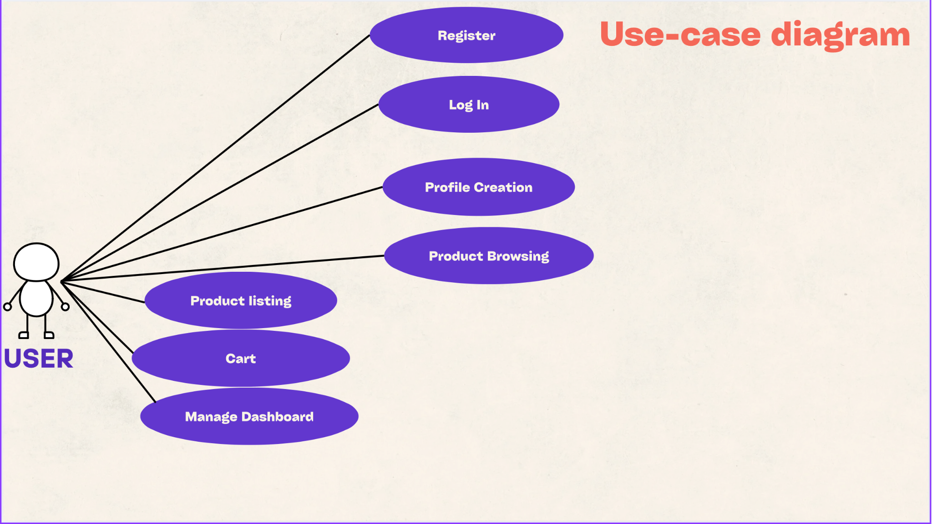

**Class Diagram**

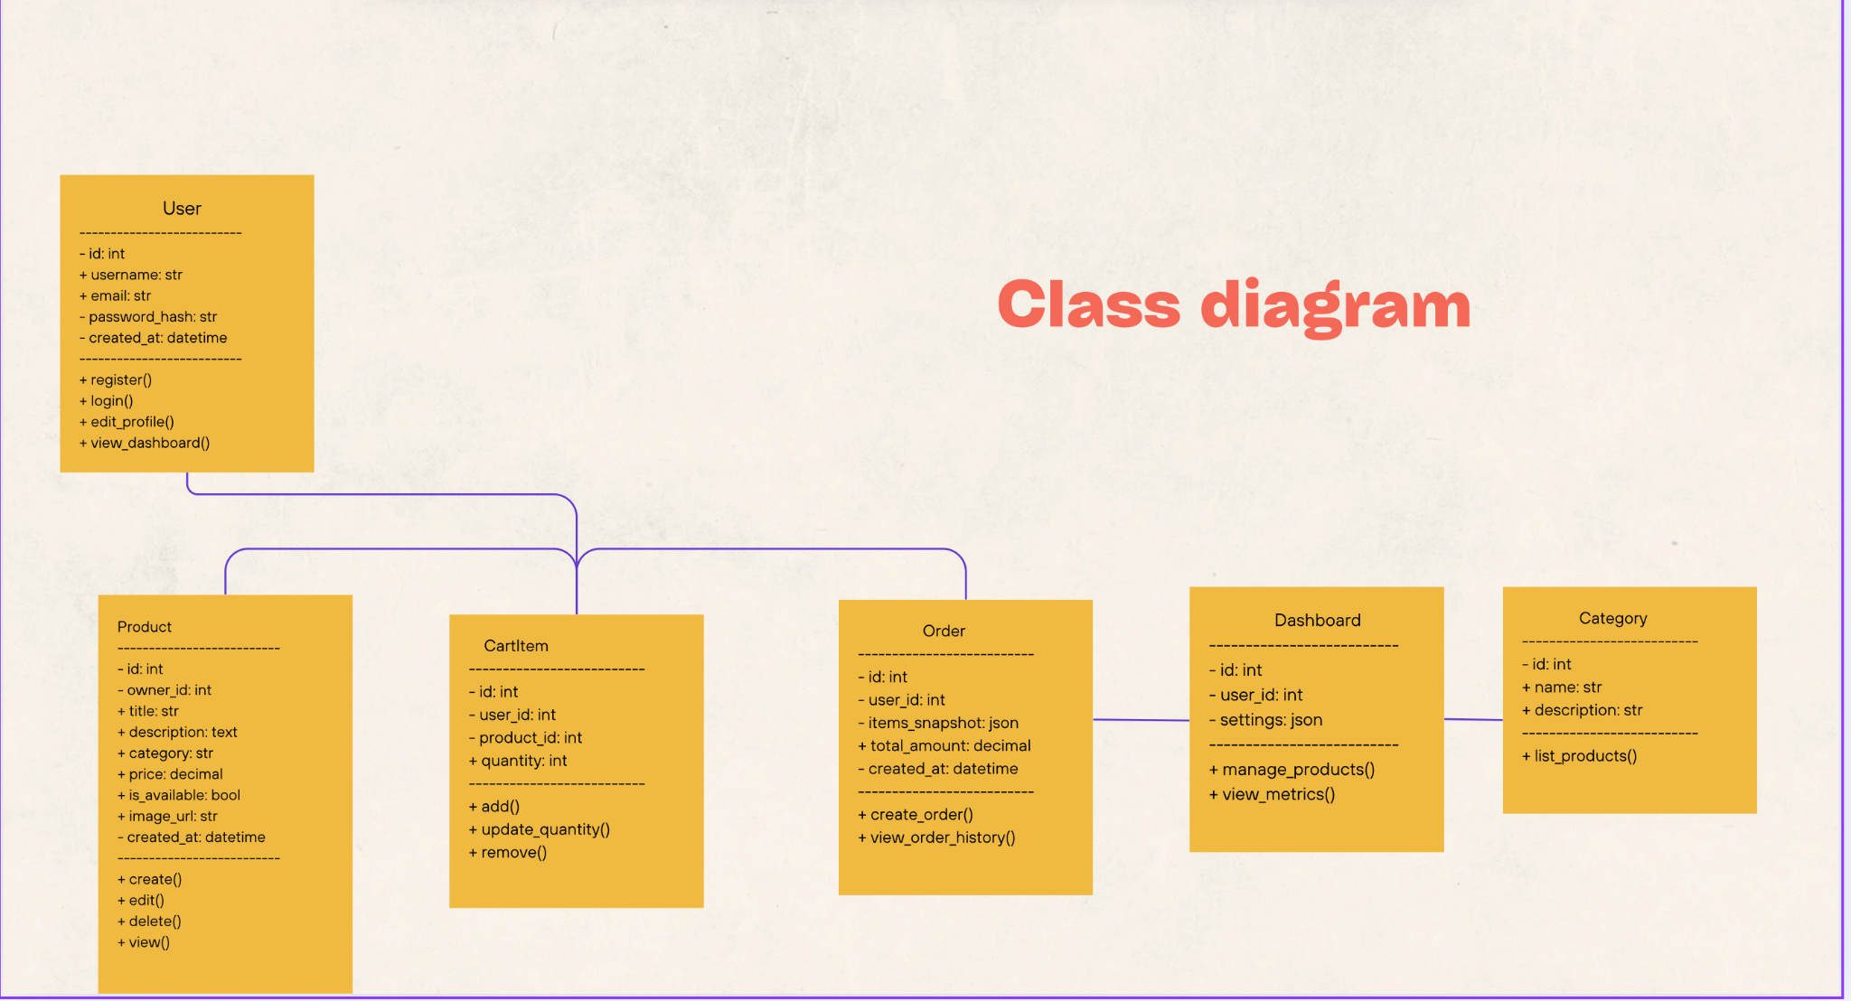

**🔤 Website Work**

**Dashboard**

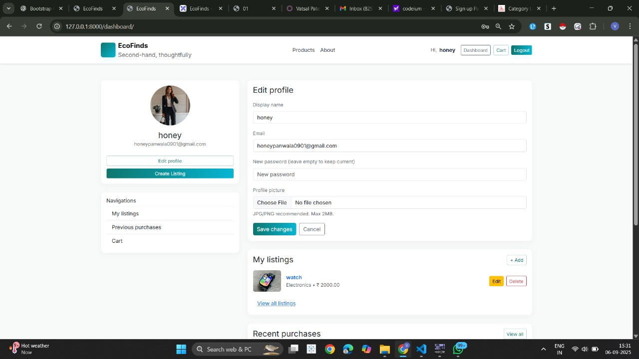

**Homepage**

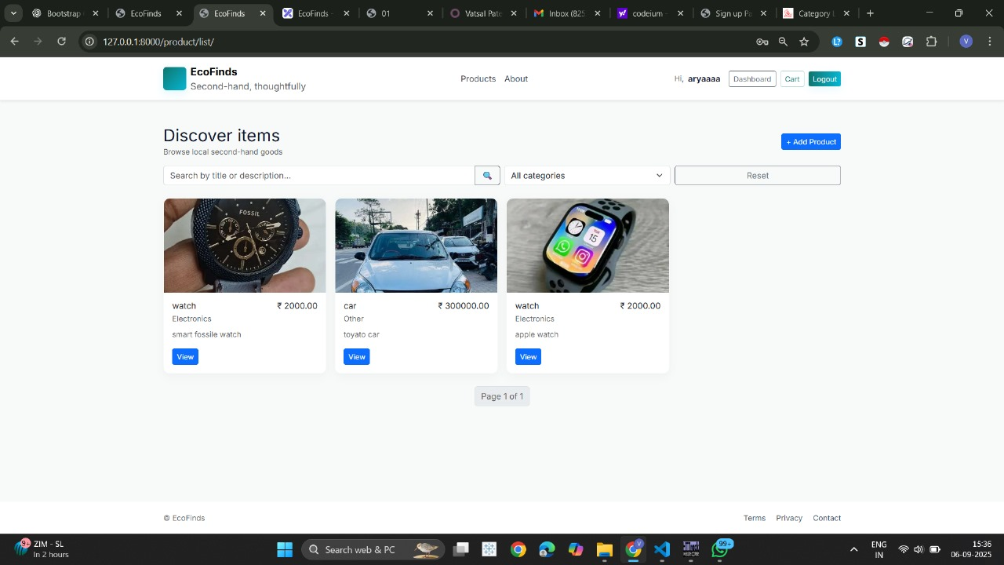

**Product Catalogue**



**Cart**

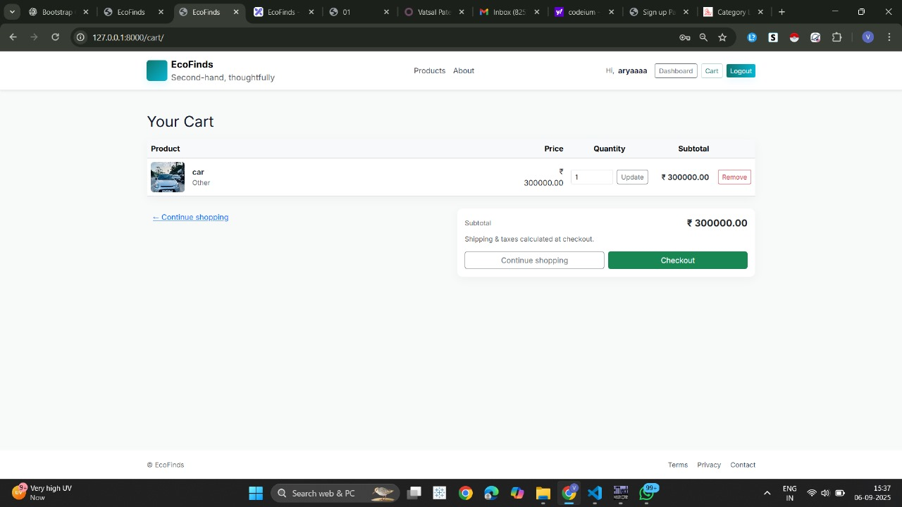

**Orders Page**



**Search**



**Conclusion**

Building EcoFinds was a journey that showed us how a clear, step-by-step approach can turn a complex idea into a working online store. We started with a simple checklist, making sure we carefully designed, built, and tested every single feature—from letting users sign in and manage products to handling shopping carts, simulating checkout, and keeping track of past orders.

Using Django's MVT setup, along with HTMX and responsive templates, we created EcoFinds as a straightforward yet complete platform that's easy to use, put together, and expand. Every step of the way, we followed clear guidelines, which not only made the process smoother but also ensured we got reliable results.

What makes EcoFinds special is how it finds the sweet spot between being fully functional and keeping things simple. By focusing on the essential e-commerce features, we avoided making it overly complicated while still showing the complete journey of a modern online transaction. Plus, the project really highlights how crucial careful planning, building in modules, and thorough documentation are—they're just as important as the technical stuff for a software project to succeed.

From both a learning and practical perspective, EcoFinds acts as:

* A guide showing how a checklist-driven approach helps get projects done.
* A working model that can be expanded to include things like payment processing, buyer-seller chat, or product suggestions.
* A showcase of best practices in clear reporting, system analysis, and design.

In a nutshell, EcoFinds achieved its goals of creating a basic, well-structured, and demonstrable online marketplace. While we know it has its limits right now (like no real payment processing or fancy analytics), it has built a strong and flexible foundation. With future improvements, EcoFinds has the potential to grow into a complete marketplace. More importantly, it proves that clarity, structure, and discipline in how we execute a project can be just as powerful as advanced technical complexity.